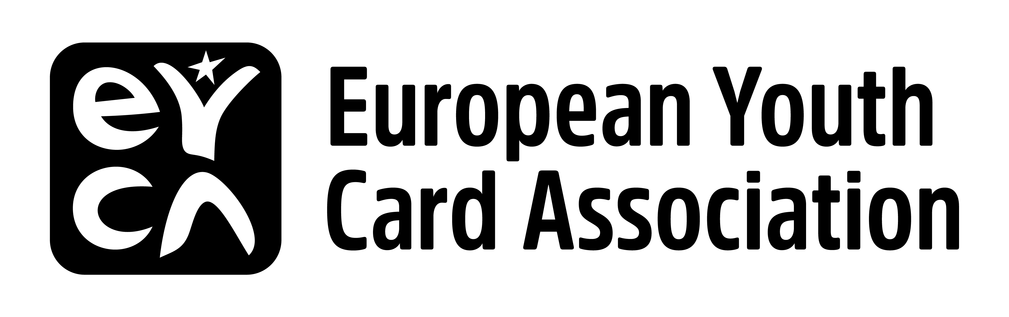
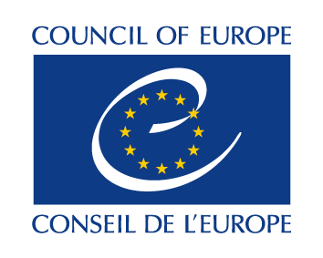

SEMINAR

From youth policies to good practices: the European Youth Card as a tool to promote access to social rights for all young people

22 – 24 April 2018
Budva, Montenegro

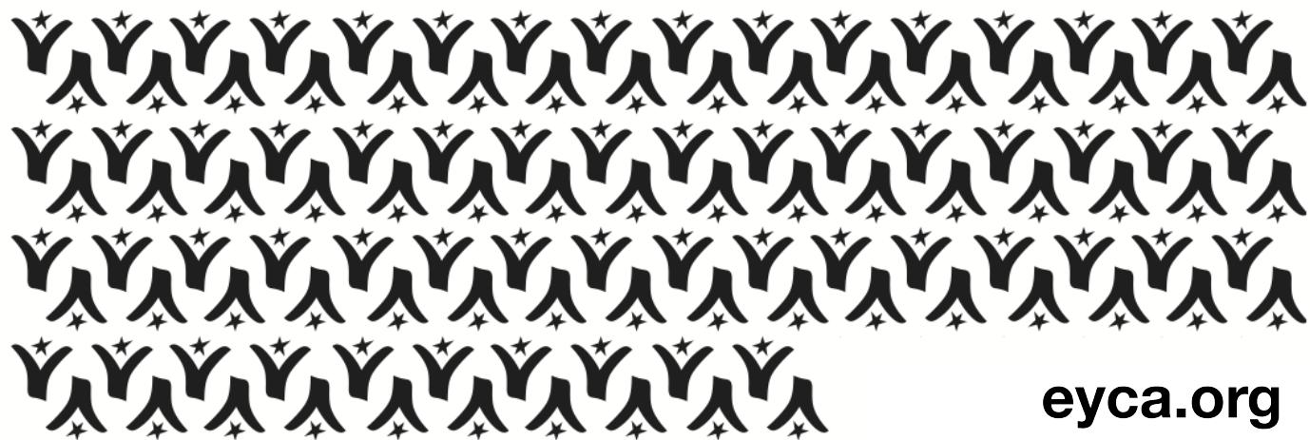

Context:

The Council of Europe is one of the leading institutions in promoting inclusive, human-rights based youth policies. With legislative framework such as the Council of Europe Charter on Education for Democratic Citizenship and Human Rights Education and The European Social Charter, citizens and governments have important mechanisms at their disposal.

However, when it comes to vulnerable population groups, especially young people, their access to civic, social and economic rights is particularly important. A series of recent Recommendations of the Committee of Ministers highlight the importance of youth work and services to ensure young people have access to their social and economic rights, are correctly informed and aware of the instruments they can use:
- youth work - CM/Rec(2017)4,
- young people access to rights - CM/Rec(2016)7
- access of young people from disadvantaged neighbourhoods to social rights - CM/Rec(2015)3

The seminar aims to identify possibilities of using the European Youth Card as a tool to reach out to the most vulnerable young persons and ensuring they have access to information that defends their social rights.

The seminar will bring together 30 participants:
- policy makers in the youth field,
- youth workers / practitioners,
- youth leaders
- EYCA member organisations.

They will get familiar with the priorities of these documents and identify opportunities of how they can actually help to implement them at local and national levels with the help of the European Youth Card.

Practical information:
Accommodation and meals will be covered by organisers. Transport will be reimbursed for all participants, upon receipt of justificative documents.

The deadline for the expression of interest is Tuesday 3 April 2018 by mid-night CET.

SEMINAR PROGRAMME

DAY 1 | SUNDAY, 22 April 2018
 | Arrival of participants
20.30 | Welcome dinner
DAY 2 | MONDAY, 23 April 2018
09.30 – 10.00 | Welcome  - Government of Montenegro representative  - CoE representative  - EYCA Director
10.00 – 10.10 | Aims and objectives of the Seminar  Presentation of the participants
KEY NOTE SPEAKERS
10.10 –11.15 | Youth: their capacity of accessing social & economic rights: how to prevent the loss of a new generation?  Suggested keynote speakers:  - EUROFUND representative (with a particular focus on young NEETs) (TBC)  - International Labor Organisation – Youth Employment Programme (TBC)
11.15 - 11.45 | Coffee break
11.45 – 12.45 | Role of youth services in promoting access to social & economic rights  Suggested speakers:  - Zdenka Maskova – Ministry of Education, Youth and Sport, Czech Republic  Youth leaders advancing social justice  - Milos Ristovski – Advisory Council on Youth (TBC)
12.45 – 14.00 | Lunch
EYCA GOOD PRACTICE ON SOCIAL INTEGRATION OF YOUNG PEOPLE & LINK TO YOUTH POLICIES
14.00 – 16.00 | Suggested member organisations to present their good practices (TBC):  - Bulgaria  - Spain (Balearic Isands)  - Albania (to be representative for the regional context)  - Malta  - Scotland
16.00 – 16.30 | Coffee break
LOCAL REALITIES
16.30 – 18.30 | Options:  - Organizing a panel discussion with various local stakeholders: Ministry, youth organisations, UN Agencies (UNDP, UNICEF), OSCE mission to Montenegro  - Visiting a youth center / youth organisation
18.30 | Free time
20.30 | Dinner
DAY 3 | TUESDAY, 24 April 2018
9.30 – 11.30 | Groups discussion  How to integrate the youth card in local / national policies and youth services that would facilitate access to social & economic rights for young people. Major topics:  - Social inclusion  - Access to quality jobs & internships (can be related with EYCA’s CSR strategy)  - Preventing and combating discrimination
11.15 - 11.30 | Coffee break
11.30 - 13.00 | Conclusions: Next steps, main messages and possible new paths to explore
13.00 | Lunch

